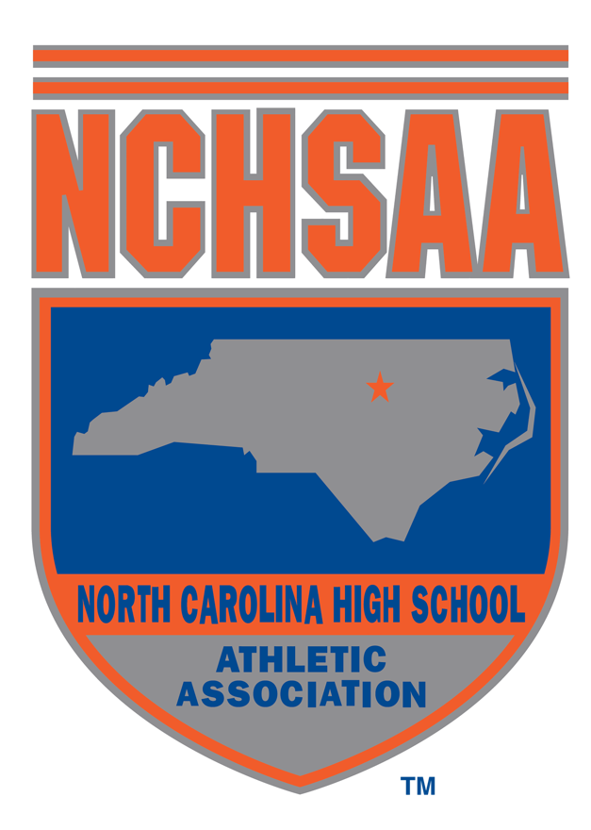

Job Description – Sports Management Intern (Fall 2022)

Title: | Sports Management Intern
Employer: | North Carolina High School Athletic Association, Inc.
Salary: | For college/university course credit; Stipend
Application Deadline | Ongoing
Reports to: | Associate/Assistant Commissioners
Commitment: | Flexible dates. Flexible hours, depending upon number of hours required; some weekend work at state championship events.
Working Hours: | Flexible; office is open M-F 7:30a-4:30p; weekend work at championships
Office Location: | Chapel Hill, NC

JOB SUMMARY

The Sports Management Internship will consist of both the operations and business aspect of high school sports. The Sports Management Intern will assist the Sports Department team members with planning and execution of various aspects related to several spring state championship events. The Sports Management Interns will assist with event site set-up and event operation support. The Intern will also assist the Marketing staff with on-site branding, social media posts, hospitality set-up and networking with special guests. Intern will participate in post-event evaluation process. Interns will receive hands on experience in numerous aspects of event management.

SPECIFIC DUTIES

Operations & Marketing:
- Provide assistance with management of event gear, supplies, digital ticketing, and vendors.
- Execution of event site set-up (branding).
- Help facilitate social media updates throughout state championship events.

Communications:
- Assistance in organizing media lists, serving as media point of contact at certain events and ensuring final scores are distributed to communications staff for event write-ups.
- Wells Fargo Cup Project
  - Help gather annual conference standings and state championship standings.
  - Calculate the annual points for each Wells Fargo Conference Cup Winner and each Wells Fargo State Cup Winner.
  - Organize final results.
  - Help facilitate the ordering and distribution of winner cups and banners.

Sports Department:

Provide support relative to the administration of all NCHSAA sports programs, i.e., championship preparation, post-event wrap up, where applicable.

Be on-site at select championship events assisting with setup, game-day management, and breakdown.

Assist with team packet distributions and facilitation of awards presentations and team photos.

Willingness to use knowledge learned in the classroom and apply it to the internship experience.

Officiating:

Assist in Rule Book preparation for NCHSAA Officials.

Health, Safety, & Wellness:

Review compliance reports for athletic trainers/first responders and reconcile with Dragon Fly.

Organize planning structure regarding health/safety preparation for championship events.

Assist with production of educational videos and other resources that pertain to health, safety, and wellness.

Other Duties:
- Assist with daily tasks leading up to the state championships events.
- Other duties as assigned.

Necessary qualifications:
- Must be at least 18 years of age and enrolled in your sophomore, junior or senior year at an accredited college or university.
- Knowledge about youth sports helpful
- Superior oral and written communications skills
- Effective organizational skills for managing multiple tasks
- Ability to lift 50 pounds
- Knowledge about Microsoft Office Suite

Stipend:

- Sports Management Interns will be paid a stipend for their three months at the NCHSAA, courtesy of Wells Fargo.
- Sports Management Interns will be required to work on-site at multiple state championship events. These events typically occur during weekends and/or non-business hours. Sports Management Interns working during these events will be paid a travel reimbursement and provided with appropriate meals.

