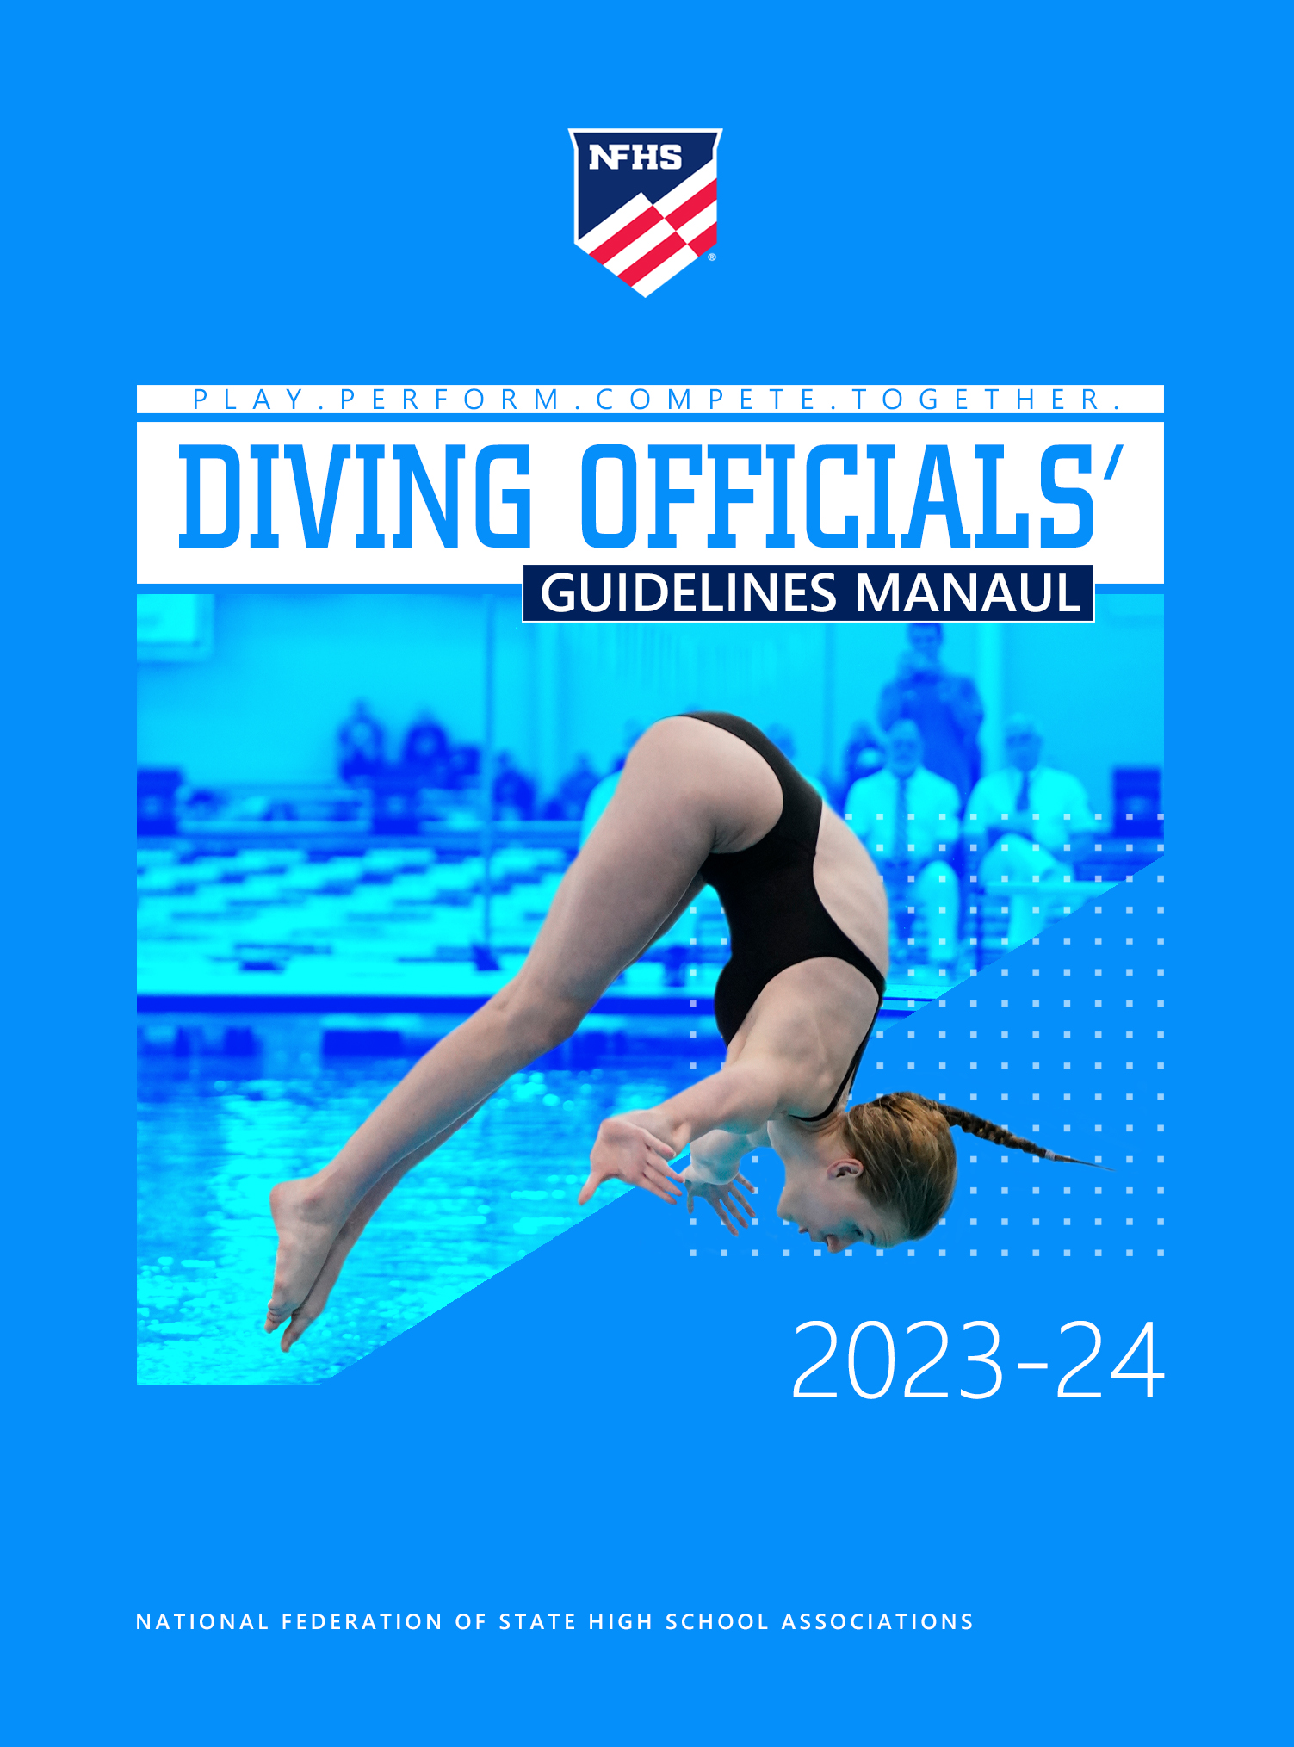



2023-24 NFHS
DIVING OFFICIALS’ GUIDELINES MANUAL

DR. KARISSA L. NIEHOFF, Publisher
Sandy Searcy, Editor
NFHS Publications

© 2023 by the National Federation of State High School Associations (NFHS). Permission is granted to copy and use in its entirety by an individual or non-profit organization solely for the purpose of training diving officials. Any other use of any portions of this document is prohibited without written permission from the NFHS.

Cover Design: Kim Vogel, NFHS
Cover photos courtesy of Minnesota State High School League.
INTRODUCTION

This manual is provided to improve the consistency of officiating high school diving. It is based on the premise that the purpose of diving judges at a meet is to ensure fair competition for all participants in accordance with the rules established by the NFHS. In order to accomplish this, officials must understand the rules and enforce all rules without regard for the outcome of the competition.

This manual is not meant to be “another rules book.” Rather, it is designed to assist all officials in understanding their role in conducting competition. While it should be especially useful for new and less experienced diving judges, it will also help the veteran judge hone the individual’s organizational skills along with the mechanics of officiating the event of one-meter diving.

PHILOSOPHY AND ETHICS

The primary role of the official is to ensure fair competition which is conducted in a positive, safe and healthy environment and that actions of the competitors, coaches and other team personnel are in compliance with the rules. In fulfilling this task, the official must establish the best possible competitive climate for fair competition with the attention on the athletes, rather than on the official. The conduct of each official affects the public’s attitude toward all officials. Therefore, every official must uphold the honor, integrity and dignity of the profession.

TABLE OF CONTENTS

Officials Code of Ethics 5
Key Points for High School Diving Officials 6
All Officials 7
The Diving Referee 8
Diving Judges 13
The Diving Announcer 14
Guidelines for Judging Diving 15
Diving Point Awards 18
Simplifying the Dive Numbers 20
One Meter Diving Table 22
NFHS Dive Silhouettes 26
Judging Dives 30
Contributors To This Publication 33


OFFICIALS CODE OF ETHICS

Officials at an interscholastic athletic event are participants in the educational development of high school students. As such, they must exercise a high level of self-discipline, independence and responsibility. The purpose of this code is to establish guidelines for ethical standards of conduct for all interscholastic officials.
Officials shall master both the rules of the game and the mechanics necessary to enforce the rules, and shall exercise authority in an impartial, firm and controlled manner.
Officials shall work with each other and their state associations in a constructive and cooperative manner.
Officials shall uphold the honor and dignity of the profession in all interaction with student-athletes, coaches, athletic directors, school administrators, colleagues, and the public.
Officials shall prepare themselves both physically and mentally, shall dress neatly and appropriately, and shall comport themselves in a manner consistent with the high standards of the profession.
Officials shall be punctual and professional in the fulfillment of all contractual obligations.
Officials shall remain mindful that their conduct influences the respect that student-athletes, coaches and the public hold for the profession.
Officials shall, while enforcing the rules of play, remain aware of the inherent risk of injury that competition poses to student athletes. Where appropriate, they shall inform event management of conditions or situations that appear unreasonably hazardous.
Officials shall take reasonable steps to educate themselves in the recognition of emergency conditions that might arise during the course of competition.
Officials shall maintain an ethical approach while participating in forums, chat rooms and all forms of social media.

KEY POINTS FOR HIGH SCHOOL DIVING OFFICIALS

- Be knowledgeable of NFHS diving rules.

- Study the NFHS Swimming and Diving Rules Book, including the situations and rulings, and attend rules meetings regularly as required by the state association or officials’ association to stay informed regarding current rules.

- Be consistent in the application of the rules at all times and at all levels of competition.

- Enforce all rules equitably and fairly. Do not allow rule infractions to go uncalled simply because no one has gained an advantage. If there is a violation, it must be called. Do not try to decide who might be unfairly affected by a violation.

- Exercise fair and unbiased judgment by disregarding a diver’s identity, team affiliation, etc.

- Mentally review what is required for a dive to score at the Excellent, Very Good, Good, Satisfactory, Deficient, and Unsatisfactory levels and what would render the performance a failed dive prior to each dive.

- Make timely decisions.

- Score only what you specifically observe. Do not guess or anticipate. Do not discuss close calls with coaches or competitors. A close call is a no call!

- Give your undivided attention to your specific assignment.

- Diving is an aesthetic sport so how a dive looks is important. In diving, scoring for all dives is to be based on technical merit, form, accuracy, height, distance and aesthetic value during all phases (start, approach, takeoff, flight, entry) of the dive. While judges may differ in how much relative weight each gives to the phases and the aspects, it is crucial that each judge must be consistent in that weighting throughout the dive meet.

- Avoid coaching athletes. At lower levels of competition, specifically junior high, the explanation of legal starting position may be given in much more detail than at higher levels of competition.

- When a coach also judges, they should be considerate to the diver on the board at all times.

- When discussing the circumstances surrounding events that occurred during the meet with other officials, wait until the meet is over or there is a scheduled break, and you are away from athletes, fans, and coaches.

- As an official, never publicly criticize another official or an official’s decision. Report any concerns about another official to the meet referee.

- Comments or discussion on a call should not take place with representatives of the media.

- Refrain from cheering or verbally supporting participants or a team while serving in an official’s role.

- Mentor and support less experienced officials, as long as it is not a distraction during a meet.

- When a mistake occurs, correct the mistake according to the NFHS rules. Do not make a decision to “make up” for a poor decision made earlier.

- Be professional and friendly when interacting with administrators, coaches, athletes, spectators, other officials, etc. Do not socialize with these individuals, as it may give the impression of favoring one team over another.

- Dress professionally in accordance with state association rules regarding official’s uniforms. Do not wear apparel that promotes any particular team or would call into question your impartiality.

- Maintain control of the meet but remember that all participants want to do their best while having a fun and enjoyable experience.

- Work a variety of meets. The more experience gained the more comfortable the official will be on deck and the more confident in observation.

ALL DIVING OFFICIALS

All officials must remember their primary purposes when on deck. Officials shall conduct the meet in a professional manner, assure compliance with the NFHS rules and assure that no competitor has an unfair advantage. Officials shall remain mindful of the inherent risk of injury that competition poses to student athletes. Where appropriate, they shall inform event management of conditions or situations that appear unreasonably hazardous.

In every meet, all swimming and diving officials should:
- Arrive at least 30 minutes prior to the scheduled start of the meet.
- Be prepared with access to a NFHS Swimming and Diving Rules Book, whistle, notepad, pen/pencil, and appropriate forms.

- Silence personal cell phone prior to the start of the meet.

- Introduce themselves to the coaches from all participating teams.

THE DIVING REFEREE
Refer to NFHS Rules 9-1 through 9-8

The diving referee is the head diving judge and has full authority over other diving judges. The diving referee’s decision is final.

Before diving competition, the diving referee should:
- Arrive at least 30 minutes prior to the scheduled start of the meet to see that the equipment necessary to conduct the one-meter diving event is in compliance with the rules. Any concern should be referred to the host team’s representative or meet manager.

- If necessary, designate a member of the judging panel to assist in determining
unsatisfactory or failed dives.

- If necessary, be sure lane lines and backstroke flags are removed from the diving area.

- Confirm all diving scoresheets/dive lists were submitted by the designated time, allowing adequate time for meet management to review prior to the competition.

- Confirm the process being utilized to obtain the diver and coach signatures when using electronic diving entries.

- Check carefully that all diving scoresheets are signed, or dive lists are initialed when using electronic entries by the diver and coach.

- Confirm the protocols to be followed by the diving referee, coaches and divers to ensure all requirements and responsibilities, by rule, are being met. Review the protocol with appropriate meet personnel to ensure smooth administration of the competition.

  - For dual meets:
    - The number of team entries in diving shall be the same as the number of team entries allowed in each swimming event. The number of team exhibition divers may not exceed the number of exhibition entries in swimming events.
    - Diving shall count as one of the athlete’s two individual entries for the meet.
    - The divers from the visiting team have the choice of selecting the odd or even diving positions. A single diver from the visiting team may select any of the odd or even positions, (i.e., 1, 3, 5), which may be different than the lanes selected for the team’s swimming lanes.
    - The diving referee, or designee, should check the diving scoresheets for the following: (This is performed as a courtesy to the diver and the coach. The primary responsibility for accuracy of the diving scoresheet lies with the diver and coach.)
      - The diver’s name and school, diver and coach signatures, dive number and position, the order in which the dives will be performed, and the designated degree of difficulty for the voluntary dive is circled and not greater than 1.8. Remember: the dive number and position are the official description of each dive;
      - Verify that all divers have the correct Voluntary Dive Group for the week: Week #1 – forward group; week #2 – back group; week #3 – inward group; week #4 – twisting group; week #5 – reverse group; then start again with the forward group (unless determined otherwise by the state association);
      - Verify that the five optional dives come from at least four of the five dive groups, and may include any dive from the voluntary dive group other than the voluntary dive; and
      - Be sure no dive is repeated on the scoresheet.
- Conduct a meeting with coaches and divers to discuss the following:
- All divers will receive two approaches with entries once the lane lines are moved and backstroke flags are taken down;
- Begin adjusting the board or have a teammate adjust the board as soon as the previous diver has gone;
- Know your order in the diving rotation (encourage naming the “on deck” diver);
- Listen carefully to the dive that is announced. If there is any problem, stop and ask the announcer to repeat or the referee for assistance;
- Divers are responsible for the accuracy of their diving sheets;
- Instruct divers regarding the procedure for exceptional events that may occur. If something unusual happens during the dive that causes a distraction or impedes performance, the diver, not their coach or another person, must request permission to repeat the dive;
- Divers must let the referee know they are going to do a standing front take-off and that they will be given a 2-point reduction in their score for a violation of the front approach;
- Divers may change the position of a dive on the board;
    - The dive referee may give permission to repeat a dive if there was obvious unfairness during an attempt and the diver was visibly too shaken to ask;
    - Allow requests by the diver to wipe water from the diving board before assuming a starting position;
    - Review rules regarding taping (divers may wear tape or wraps for support; may also use temporarily applied adhesives);
    - Review any special rules which will apply to the competition;
    - Review rule concerning re-entering the water between dives.

  - For 11-dive meets:
    - The number of team entries for invitationals shall be determined by the meet management.
    - The order in which the divers shall perform shall be determined by the meet director and shall be by lot or by seeding based on the diver’s best competitive 11 dive score submitted. If seeding and no 11-dive score is submitted, the diver shall be seeded by lot at the beginning of the diving order. The same relative position in the diving order shall be maintained by the divers throughout all levels of the competition; however, the diving finalists may be seeded based on the semifinal scores (lowest to highest) or kept in the same dive order as the preliminaries and semifinals, as determined by the meet director.
      - The default method for determining the order of the diving competition shall be by lot for a championship meet or meet conducted under a championship format.
    - The diving referee, or designee, should check the diving scoresheets for the following: (This is performed as a courtesy to the diver and coach. The primary responsibility for accuracy of the diving scoresheet lies with the diver and coach.)
      - The diver’s name and school, diver and coach signatures, dive number and degree of difficulty for voluntary dive(s) circled (if electronic diving entries are being used, the voluntary dives will be identified as such, but not circled), position, written description, degree of difficulty, and the order the dives will be performed. Remember: the dive number and position are the official description of each dive;
      - All divers have 11 dives listed;
      - Verify that the five voluntary dives (two in the preliminary round, two in the semifinal round and one in the final round) come from each of the dive groups with their assigned degree of difficulty and have a sum total of 9.0, or less;
      - Verify that the six optional dives include at least one from each of the five groups and that no more than one optional dive from the same group is performed through the semifinals (i.e., first eight rounds);
      - Verify that all five groups are represented in the first eight rounds of competition and no dive is repeated.
      - Conduct a meeting with coaches and divers to discuss the following:
  - The order in which the divers will perform;
  - If more than one board is available, discuss any restriction/limit on which board is used during either warm-ups or competition;
  - Practice dives are permitted during specified warm-up times. Divers shall be permitted at least two practice approaches, with or without a water entry immediately prior to the start of the diving competition or after a break of ten minutes or more. Boards will be open for practice during the time it takes for cuts to be made in a championship meet unless the meet director has established specific guidelines prior to the competition.
  - Responsibility for diving sheets rests with the diver;
  - Listen carefully to the dive that is announced. If there is any problem, stop and ask the announcer to repeat or referee for assistance;
  - Instruct divers regarding the procedure for exceptional events that may occur. If something unusual happens during the dive that causes a distraction or impedes performance, the diver, not their coach or another person, must request permission to repeat the dive;
  - Inform the divers that they must let the referee know they are going to do a standing front take-off and that they will be given a 2-point reduction in their score for a violation of the front approach;
  - Remind divers that they may change the position of a dive on the board;
  - The diving referee may give permission to repeat a dive if there was obvious unfairness during an attempt and the diver was visibly too shaken to ask;
  - Allow requests by the diver to wipe water from the diving board before assuming a starting position;
  - Review rules regarding taping (divers may wear tape or wraps for support and may also use temporarily applied adhesives);
  - Any special rules which will apply to the competition;
  - Review rule concerning re-entering the water between dives.

- Meet with the other diving judges to review calls by the referee, individual judges’ responsibilities, the scale for awarding points, their locations while judging diving and discuss any other unique circumstances related to diving.

- The following areas should be covered:
  - The designated panel member assisting with calls should sit on the opposite side of the pool whenever possible;
  - With the exception of the designated panel member, judges should NOT discuss or make comments regarding dives with other judges until after the scores are awarded;
  - If a judge is also a coach, it is only appropriate for that coach to talk to their own divers;
  - Review mandatory deduction for a balk or violation of the forward approach as determined by the diving referee; and
  - Not showing their score until it is called for and when called not delaying showing the score.

During the diving competition, the diving referee should:
- Request quiet from spectators and competitor. This applies to all meets unless swimming and diving are being conducted simultaneously.

- Require the announcer to announce the order of divers followed by the first dive.

- Keep a record of all failed dives, in order to know when a diver has failed two dives and is disqualified. If there is a disqualification, immediately notify the diver and the coach and provide reasoning.

- Determine disqualifications as per the NFHS rules and notify the competitor and/or the coach immediately.

- Determine and announce failed dives, including declared false starts (choosing not to participate in the diving event), as per the NFHS rules (Rules 9-6-2 and 3-2-3).

- Allow divers to withdraw from the competition and treat this the same as a declared false start taken by swimmers.

- Deduct two points from each judge’s award for a violation of the forward approach or a balk as per the NFHS rules.

- A violation of the forward approach occurs when the diver does less than the required three steps.
Note 1: A violation of the forward approach occurs when the diver does less than the required three steps or does not go from one foot to two feet in the hurdle.
Note 2: A forward standing takeoff is considered a violation of the forward approach.

- A balk is declared if in the referee’s opinion, after a diver assumes the starting position for a forward approach, forward standing take-off, or back take-off the diver makes an obvious attempt to start the approach or press and stops the continuous execution of the dive. The balk is declared before the dive is scored.

- Declare an unsatisfactory dive when:
  - The dive is clearly done in a position other than what is written on the scoresheet;
  - The diver hits the board;
  - The diver’s head is unsafely close to the diving board during the dive;
  - The diver does not attempt to come out of a tuck or pike position;
  - The diver does not attempt to come out of a twist;
  - The diver does not hold the straight position until the body is horizontal to the water on any flying one somersault dives or does not hold the straight position until the body is perpendicular to the water on any flying one and one-half somersault dives;
  - The diver does not declare a forward standing takeoff.

- Not invoke a penalty unless the diving referee is absolutely certain it is warranted. The diving referee may confer with another judge only regarding the determination of an unsatisfactory or failed dive.

Following the diving competition, the diving referee should:
- Review, or designate other diving officials to review the scoresheets for accuracy. When electronic scoring is not used it is important to check the math for accuracy and resolve any problems before announcing the final scores. Establish the order of finish and have the scores announced.

- Sign the diving scoresheet.

DIVING JUDGES
Refer to NFHS Rules 9-7 and 9-8

While there are many aspects to being a good diving judge, knowledge of the rules is paramount. Knowing the rules regarding the five elements of all dives (starting position, approach, takeoff, flight and positions, and entry into the water) is essential to being a competent diving judge. It is important for diving judges to review the diving guidelines and/or silhouettes frequently.

Diving judge should:
- Be sure to consider all five elements of a dive when scoring. Judge the entire dive independently and select a score promptly upon completion of the dive. Avoid the trap of having the last element—the entry—become the most important determinant of the score.

- Be consistent and fair to all the divers. Score all divers on the same basis.

- Remember the specific rules requiring deductions by a diving judge.

- Trust your instincts, judge what is observed and use the entire range of numbers 10-0. Do not allow outside factors such as other judges, spectators, coaches and/or team members to enter into the judging process. Individual judges do not have to agree with the rest of the panel; the score in the middle isn’t always the correct one.

- Know the description of each of the judging categories (Excellent, Very Good, Good, Satisfactory, Deficient, Unsatisfactory and Failed), and score each dive based on the scores within each category.

- If in doubt, give the benefit to the diver.

- Show the score for a dive when it is called for without delay.

- Expect properly executed dives to be performed in front of the board and at an appropriate distance from the board and walls.

It is important to hear the announcer read the dive and dive description in order to develop a mental picture of the dive to be completed. Begin judging the dive when the starting position has been established and do not stop judging the dive until the diver has passed below the surface of the water. Once the dive is completed, select a score quickly without consulting another diving judge. If there is an error in a score read by the announcer, immediately bring it to the attention of the diving referee.

The diving referee determines failed and unsatisfactory dives and mandatory deductions. An unsatisfactory dive results in a maximum score of two points, but that does not mean that a judge is obligated to show a score of two points, especially if there were deficiencies requiring mandatory deductions or deficiencies in other elements of the dive. A score of 0 can be shown without the dive having been declared a failed dive and the score itself would not mean that the dive would be considered a failed dive.
The judging panel may or may not include the diving referee (Rule 9-6-1).

A diving judge, who is also serving as a participating school coach, may converse with their diver(s) at times determined by the diving referee, but may not do so when it will distract the diving judge from a dive being performed by another diver. (Note: Coaches may only officiate if it is allowed by their state association.)
THE DIVING ANNOUNCER
Refer to NFHS Rule 9-6-3

The diving announcer should:
- Be familiar with diving and review the dive sheets prior to competition in order to clarify any questions. This is a good opportunity to review for correct pronunciation of names.

- Make any announcements directed by the diving referee, (i.e., no flash photography, quiet during competition, etc.).

- Announce the order in which the divers will perform.

- Announce each dive in the following manner: “Name of the diver, dive number, position, dive description, and degree of difficulty.” Make this announcement clearly to be certain the competitors and diving judges hear this information.

- If a dive is executed other than what was announced and is properly listed on the scoresheet, it will be judged as a correct dive and considered an announcer error. If the diver executes a dive as announced and it is determined that the announcer was in error, the diver will be allowed to immediately perform the correct dive. However, the diver may elect to keep the scores for the incorrectly announced dive, with the referee making an immediate correction on the diving sheet.

- It is good practice to announce the name of the “on-deck” diver in the first round of each session.

- Announce the judges’ scores in the same order every time, as has been determined by the diving referee. Wait until all scores are posted before announcing.

- Under championship format, announce the names and places, or names and scores, of the divers at the completion of the preliminary and semifinal rounds for those advancing to the next round of competition.

- Announce the final individual scores at the conclusion of the event.

GUIDELINES FOR JUDGING DIVING
Refer to NFHS Rules Book Appendix C

Starting Position
- Forward – The diver should demonstrate good posture with arms in a position of the diver’s choice.

- Back/inward – The diver should demonstrate good posture, with the head upright, arms in a position of the diver’s choice. A diver may move the arms to a variety of preparatory positions provided there is no attempt to start the dive.

Approach
- Forward – The approach shall begin with not less than three steps and finish with a hurdle, defined as a jump off one foot to a landing on both feet at the end of the board. The diver may use steps, hops, leaps and/or jumps during the initial steps and before the culminating hurdle. The forward takeoff shall be from both feet simultaneously to an adequate height to perform the dive. The hops, leaps and/or jumps shall be considered as "steps".

Hurdle
- The last step in the forward approach, called the hurdle, consists of the diver lifting the leg (diver’s choice of which leg) to form an angle that may be approximately 90 degrees at the hip and knee. The other leg pushes down on the board and helps the diver jump to the end of the board where he/she lands on two feet. The hurdle is the foundation for the rest of the dive, thus an important element for judges to observe.

Back Press - on back and inward groups, the back press combines the starting position, approach and hurdle.
- The diver should stop oscillating the board with the feet to assume a starting position. Once the diver assumes the starting position, the board can be oscillated up to four times prior to the diver leaving the board. The oscillations shall not be so large as to disrupt the tempo or smoothness of the dive. At NO time should the balls of the feet/foot lose contact with the board. If the feet/foot leave the board, or more than four oscillations occur before the diver leaves the board, or the diver takes excessively large oscillations, the judge may deduct ½ - 2 points.

Takeoff
- The takeoff should be balanced and controlled so as to allow the diver to achieve good height and appropriate distance from the springboard. The posture should be upright and pleasing to the eye.

- Balance on the balls of the feet should be maintained (on both a forward approach landing and a back press) as the arms swing around and move in time with the leg push to assist lift from the board. Too much lean forward or backward will affect the divers balance, power, distance and ultimately the success of the dive.

Flight
- The dive should have adequate height to provide enough time in the air to complete the rotation and allow the dive to travel a safe distance from the board.

- Ideally a diver should exhibit strength and power while displaying grace and beauty.

- The overall form of the diver must also be considered, as well as speed of rotation and twist mechanics in twisting dives.

- The dive position (tuck, pike or straight) should be clearly defined. Good form should be displayed by means of body flexibility, firmness, and toe point which should be maintained throughout the entire dive flight. The arms may be in the position of the diver’s choice. Just prior to the entry into the water, the arms should be brought together and extended beyond the head in line with the body for a head-first entry or against the sides of the body with straight elbows for a feet-first entry.

- Straight position (A) – The body shall not be bent either at the knees or hips. The feet shall be together and the toes pointed. The position of the arms is at the option of the diver.

- Pike position (B) – The body shall be bent at the hips, the legs must be kept straight at the knees, the feet shall be together, and the toes pointed. The position of the arms is at the option of the diver.

- Tuck position (C) – The body shall be compact, bent at the knees and hips, with the knees and feet close together within the body line of the shoulders. The hands shall be on the lower legs and the toes pointed.

- Free position (D) – The free position is not really a body position but a combination of the other three positions and is used most often to perform twisting dives. The combinations should be well defined using the positions described above.

NOTES:
- Flying one somersault dives require the diver to hold the straight position until the body is horizontal to the water (9-7-4e).
2. Flying one and one-half somersault dives require the diver to hold the straight
position until the body is perpendicular to the water.

Entry
- The entry into the water should be as vertical as possible with the body straight and toes pointed. The diver’s line into the water is only one segment of the total dive and should not be over judged.

- The dive should not be too close, too distant or off to the side of the springboard. If the diver’s head is six inches or less from the end or the side of the board as it passes through the plane of the board, the dive should be considered too close and unsafe, and the dive should be scored as unsatisfactory. The diving referee will make the call and instruct diving judges to score as such.

- Twist on Entry - the dive should be square (without any twist) as it enters the water.

- A properly performed dive will result in an entry with minimum splash. An exceptionally good entry will have little to no splash. This is commonly called a “rip” entry. Rip entries are impressive and are essential to the overall impression. However, since the entry is the last part of the dive seen, it is easy to judge the dive solely on the entry, forgetting mistakes on other elements of the dive. Avoid this common trap and score the dive based on all of its elements.

- The dive is completed and scored when the body passes through the surface of the water. What happens after the diver passes through the surface of the water should not affect the judges score.

- Properly executed dives should be performed a safe distance from the board and walls.

- Two elements a judge should not consider are the approach to the starting position of a dive and a diver’s movements beneath the surface of the water.

DIVING POINT AWARDS
Refer to NFHS Rule 9-7

Score | Description
10 | Excellent – No visible flaws – Approach, hurdle, height, distance, execution and entry are all exceptional.
8½ – 9 ½ | Very Good – Approach, hurdle, height and/or distance slightly affected. Execution well defined.
7 – 8 | Good – Approach and hurdle adequate. Height and distance acceptable. Execution defined, entry controlled, but slightly affected.
5 – 6½ | Satisfactory – Approach and hurdle acceptable. Height and distance adequate. Execution complete and entry over or under.
2½ – 4½ | Deficient – Approach and/or hurdle affected. Height and/or distance inadequate. Execution affected and entry over or under.
½ – 2 | Unsatisfactory – Approach and hurdle affected. Height and distance inadequate. Execution not complete or broken position. Entry significantly affected.
0 | Failed.

Diving judge’s deductions:
- Deficient dives:
  - The diver partially alters the position of the dive during flight;
  - A diver enters the water with one or both hands above the shoulders on a dive requiring a feet-first entry, or with one or both hands below the shoulders on a dive requiring a head-first entry.

- Mandatory ½ – 2-point deduction:
  - Not stopping the oscillations of the board just before or after the starting position is assumed in a back/inward takeoff;
  - Excessive oscillation during a back/inward takeoff;
  - Feet/foot leaving the board prior to a back/inward takeoff (crow hop);
  - Obviously spreading knees in the tuck position outside the shoulders;
  - Entering the water to the side of the board, and;
  - Twisting manifestly from the board.

Diving referee’s deductions:
- 2-point deduction from each judge’s score for:
  - Violations of the forward approach;
  - Standing forward takeoffs (considered a violation of the forward approach);
  - Balks (declared before the diving judges have scored the dive). It is a balk if the diving referee believes the diver assumes the starting position, makes an obvious attempt to start the approach or press, and stops the continuous execution of the dive prior to the water entry. An illegal forward approach occurs when a diver does less than the required three steps.

- Unsatisfactory dive (maximum score of 2 points):
  - A dive clearly done in a position other than that described on the diving scoresheet;
  - A diver hits the diving board;
  - The diver’s head is unsafely close to the diving board during the dive;

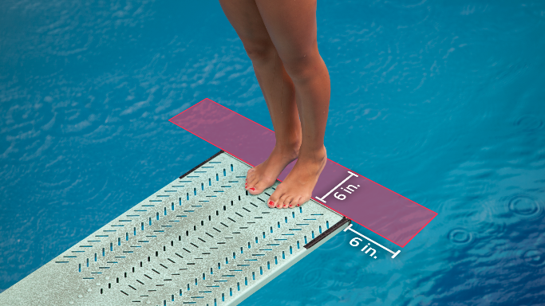

  - A diver not attempting to come out of the tuck or pike position;
  - A diver does not attempt to come out of the twist;
  - The diver does not hold the straight position until the body is horizontal to the water on any flying one somersault dives or does not hold the straight position until the body is perpendicular to the water on any flying one and one-half somersault dives.
  - The diver does not declare a standing forward takeoff.

- Failed dive (0 points awarded):
  - Executing a dive other than what appears on the diving scoresheet;
  - Not assuming a starting position;
  - Falling into the water;
  - Being assisted by another person;
  - Not executing the pike before the twist for dives #5111B and #5411B;
  - Does not contact the water with the head or hands first on a head-first dive or with the feet first on a feet-first dive;
  - Executes a twist, as determined by the diver’s shoulder position, more or less than 90 degrees indicated on the diving scoresheet when the diver’s feet/hands contact the water;
  - In a twisting dive, twist the shoulders past 90 degrees before the feet leave the board;
  - Repeats a dive;
  - Steps off the board after assuming the starting position (without permission);
  - Does not record the official description of the dive (dive number and position) on the diving scoresheet;
  - Commits two balks on the same dive;
  - In a dual meet, does not perform the voluntary dive first;
  - In a championship meet, does not perform the voluntary and optional dives as specified;
  - Performs a dive not listed on the diving table, or submits a dive not listed on the diving table that is not corrected prior to the start of competition;
  - Performs an additional bounce(s) on the end of the board after the culminating hurdle.

- Disqualifications by the diving referee:
  - Diver does not make a sincere attempt to perform the dive;
  - It becomes obvious the dives listed on the diver’s scoresheet are too difficult for the diver to perform;
  - Diver unnecessarily delays in the performance of a dive;
  - Diver behaves in an unsporting manner;
  - Diver fails two dives.
Note: Unsatisfactory dives that receive a 2-point deduction are not considered fail dives because they technically score points and then receive a deduction. They are considered Zero Sum Dives.
Examples are:
- failing to come out of a somersault after committing a balk;
- doing a dive in clearly the wrong position on an undeclared standing forward take-off;
- balking and then hitting the board;
- failing to come out of a twist with a balk or undeclared standing forward takeoff.

Generally, "Failed Dives" are declared by the diving referee however, when the referee gives the diver the benefit of the doubt and allows a dive to be scored and all judges give it zeros it would be a fail dive.

SIMPLIFYING THE DIVE NUMBERS

The meaning of the dive numbers:
- It is important for a diving judge to know the meaning of the dive numbers so they can begin to prepare to judge the dive when it is announced. The dive number and position define the dive to be performed.

      - 100’s = forward dives
  - 200’s = back dives
  - 300’s = reverse dives
  - 400’s = inward dives
  - 5000’s = twisting dives

- Position designations:

    - Straight or layout position = “A”
    - Pike position = “B”
    - Tuck position = “C”
    - Free position = “D”

- For forward, back, inward and reverse dives:
  - The first number indicates the direction of travel;
  - The second number indicates whether the dive utilizes the flying position
    - 0 = not a “flying” dive
    - 1 = “flying” dive

  - The third number indicates the number of half somersaults;

    - 2 = 1 somersault
    - 3 = 1½ somersaults
    - 4 = 2 somersaults, etc.
  - 1, 2 or 3 somersaults = a feet-first entry;
  - 1½, 2½ or 3½ = a head-first entry;
  - Dives with an odd third number should always enter the water head-first;
  - Dives with an even third number should always enter the water feet-first.

- For twisting dives:
  - The first number indicates the dive will be from the twist group;
  - The second number indicates the direction of travel;
  - The third number indicates the number of half somersaults;
    - 1 = ½ somersault
    - 3 = 1½ somersaults
    - 4 = 2 somersaults

  - The fourth number indicates the number of half twists to be performed.
    - 1 = ½ twist
    - 2 = 1 full twist
    - 3 = 1½ twists
    - 4 = 2 full twists
    - 5 = 2½ twists
    - 6 = 3 full twists

See the chart below for examples of what the four numbers in a twisting dive mean.

Group | Category | Somersaults | Twists
5 | 1 | 3 | 2
Twisting | Forward | # of ½ SS | # of half Twists

- Twisting dives with a head-first entry
Dive Group | 0, 1, 2, 3 Twists | ½, 1½, 2½ Twists
Forward | Facing the board | Looking away
Back | Looking away | Facing the board
Reverse | Facing the board | Looking away
Inward | Looking away | Facing the board

- Twisting dives with a feet-first entry
Dive Group | 0, 1, 2, 3 Twists | ½, 1½, 2½ Twists
Forward | Looking away | Facing the board
Back | Facing the board | Looking away
Reverse | Looking away | Facing the board

ONE METER DIVING TABLE

Any dive from a group may be designated as a voluntary dive. It will receive its assigned degree of difficulty through 1.8. Any voluntary dive with a degree of difficulty greater than 1.8 will be assigned a degree of difficulty of 1.8.

NFHS One Meter Diving Table

Dive No. | Forward Dives | C  Tuck | B  Pike | A  Straight | D  Free
101 | Forward Dive | 1.2 | 1.3 | 1.4 | ---
102 | Forward 1 SS | 1.4 | 1.5 | 1.6 | ---
103 | Forward 1½ SS | 1.6 | 1.7 | 2.0 | ---
104 | Forward 2 SS | 2.2 | 2.3 | --- | ---
105 | Forward 2½ SS | 2.4 | 2.6 | --- | ---
106 | Forward 3 SS | 2.9 | 3.2 | --- | ---
107 | Forward 3½ SS | 3.0 | 3.3 | --- | ---
112 | Forward Flying 1 SS | 1.6 | 1.7 | --- | ---
113 | Forward Flying 1½ SS | 1.8 | 1.9 | --- | ---
Back Dives |  | C | B | A | D
201 | Back Dive | 1.5 | 1.6 | 1.7 | ---
202 | Back 1 SS | 1.5 | 1.6 | 1.7 | ---
203 | Back 1½ SS | 2.0 | 2.3 | 2.5 | ---
204 | Back 2 SS | 2.0 | 2.3 | --- | ---
205 | Back 2½ SS | 3.0 | 3.2 | --- | ---
Reverse Dives |  | C | B | A | D
301 | Reverse Dive | 1.6 | 1.7 | 1.8 | ---
302 | Reverse 1 SS | 1.6 | 1.7 | 1.8 | ---
303 | Reverse 1½ SS | 2.1 | 2.4 | 2.7 | ---
304 | Reverse 2 SS | 2.1 | 2.4 | --- | ---
305 | Reverse 2½ SS | 3.0 | 3.2 | --- | ---
Inward Dives |  | C | B | A | D
401 | Inward Dive | 1.4 | 1.5 | 1.8 | ---
402 | Inward 1 SS | 1.6 | 1.7 | --- | ---
403 | Inward 1½ SS | 2.2 | 2.4 | --- | ---
404 | Inward 2 SS | 2.8 | 3.0 | --- | ---
405 | Inward 2½ SS | 3.1 | 3.4 | --- | ---
412 | Inward Flying SS | 2.0 | 2.1 | --- | ---
413 | Inward Flying 1½ SS | 2.7 | 2.9 | --- | ---
Twist Dives |  | C | B | A | D
5111 | Forward Dive, ½ Twist | 1.6 | 1.7 | 1.8 | ---
5112 | Forward Dive, 1 Twist | --- | 1.9 | 2.0 | ---
5121 | Forward 1 SS, ½ Twist | --- | --- | --- | 1.7
5122 | Forward 1 SS, 1 Twist | --- | --- | --- | 1.9
5124 | Forward 1 SS, 2 Twists | --- | --- | --- | 2.3
5126 | Forward 1 SS, 3 Twists | --- | --- | --- | 2.8
5131 | Forward 1½ SS, ½ Twist | --- | --- | --- | 2.0
5132 | Forward 1½ SS, 1 Twist | --- | --- | --- | 2.2
5134 | Forward 1½ SS, 2 Twists | --- | --- | --- | 2.6
5136 | Forward 1½ SS, 3 Twists | --- | --- | --- | 3.1
5142 | Forward 2 SS, 1 Twist | 2.6 | 2.7 | --- | ---
5152 | Forward 2½ SS, 1 Twist | 3.0 | 3.2 | --- | ---
5211 | Back Dive, ½ Twist | --- | --- | 1.8 | ---
5212 | Back Dive, 1 Twist | --- | --- | 2.0 | ---
5221 | Back 1 SS, ½ Twist | --- | --- | --- | 1.7
5222 | Back 1 SS, 1 Twist | --- | --- | --- | 1.9
5223 | Back 1 SS, 1½ Twists | --- | --- | --- | 2.3
5225 | Back 1 SS, 2½ Twists | --- | --- | --- | 2.7
5227 | Back 1 SS, 3½ Twists | --- | --- | --- | 3.2
5231 | Back 1½ SS, ½ Twist | --- | --- | --- | 2.1
5233 | Back 1½ SS, 1½ Twists | --- | --- | --- | 2.5
5235 | Back 1½ SS, 2½ Twists | --- | --- | --- | 2.9
5251 | Back 2½ SS, ½ Twist | 2.7 | 2.9 | --- | ---
5311 | Reverse Dive, ½ Twist | --- | --- | 1.9 | ---
5312 | Reverse Dive, 1 Twist | --- | --- | 2.1 | ---
5321 | Reverse 1 SS, ½ Twist | --- | --- | --- | 1.8
5322 | Reverse 1 SS, 1 Twist | --- | --- | --- | 2.0
5323 | Reverse 1 SS, 1½ Twists | --- | --- | --- | 2.4
5325 | Reverse 1 SS, 2½ Twists | --- | --- | --- | 2.8
5331 | Reverse 1½ SS, ½ Twist | --- | --- | --- | 2.2
5333 | Reverse 1½ SS, 1½ Twists | --- | --- | --- | 2.6
5335 | Reverse 1½ SS, 2½ Twists | --- | --- | --- | 3.0
5351 | Reverse 2½ SS, ½ Twists | 2.7 | 2.9 | --- | ---
5411 | Inward Dive, ½ Twist | --- | 1.7 | 2.0 | ---
5412 | Inward Dive, 1 Twist | --- | 1.9 | 2.2 | ---
5421 | Inward 1 SS, ½ Twist | --- | --- | --- | 1.9
5422 | Inward 1 SS, 1 Twist | --- | --- | --- | 2.1
5432 | Inward 1½ SS, 1 Twist | --- | --- | --- | 2.7
5434 | Inward 1½ SS, 2 Twists | --- | --- | --- | 3.1

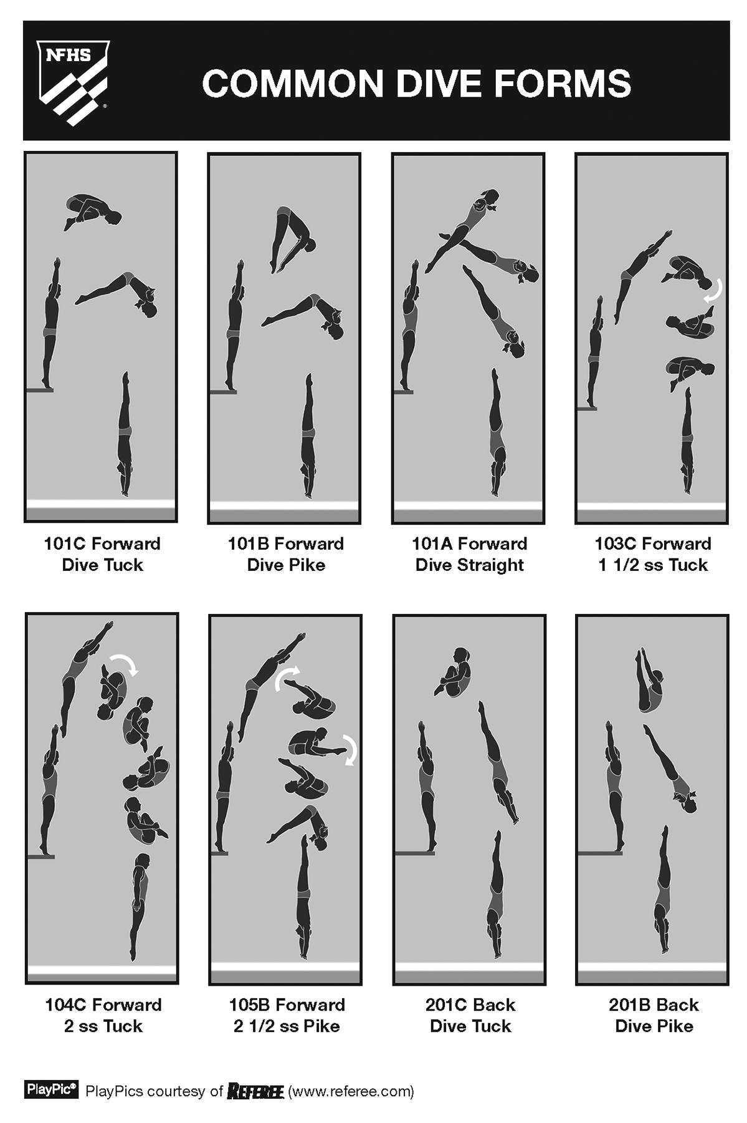
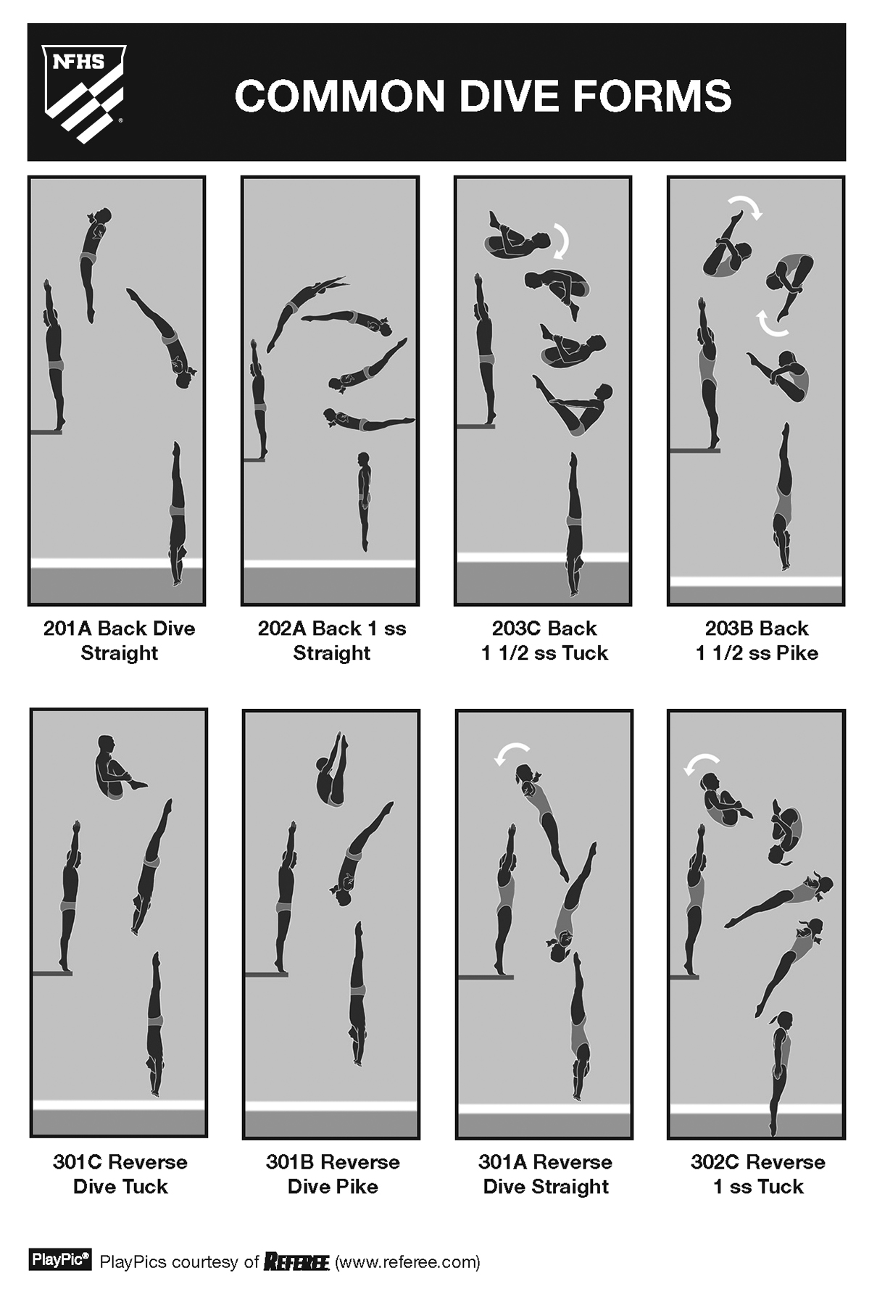
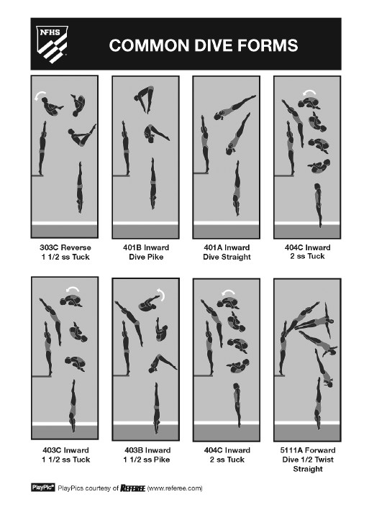

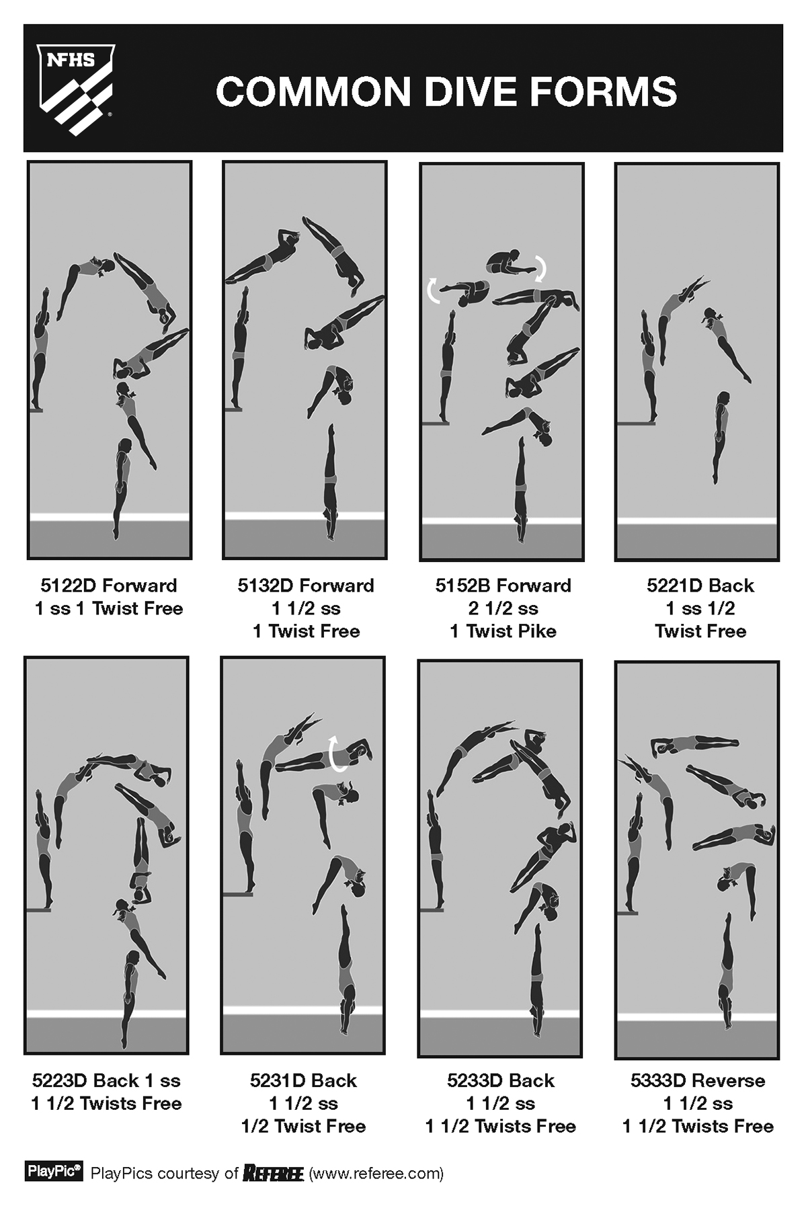
Judging Dives

The art of judging diving is not only a question of having sufficient knowledge of the NFHS Rules Book as, in reality, the written rules are the easiest part of judging. The difficulty is in mastering the unwritten rules and factors which influence all diving judges, both consciously and unconsciously.

Knowledge of the sport. Obviously, knowledge of the sport is essential. However, no person is born with it. It can be acquired by learning to dive under good instruction, studying the NFHS Rules Book and other texts/rules, participating in judging seminars, discussing the sport with knowledgeable persons, and most importantly, by observation in person and by viewing videotapes, films, and other media. A great deal can be learned about the sport by studying videos of all levels of diving and getting exposure to as many diving competitions as possible. No judge, however seasoned, should stop studying and observing. Even the real experts lose their “diving eye” after several months without contact with diving. It is very important to stay up to date on the rules and developments of this dynamic sport. Many divers in high school diving programs also participate in USA Diving affiliated clubs; there are some differences in rules and judging standards that, on occasion, athletes, coaches and parents do not understand.

Patience, patience, patience. There are several reasons a diving judge needs patience. First, most problems occur during a diving contest are not described in the rules. No written rule describes, for instance, the difference between scores of 7, 7.5 and 8 for a “good” dive. The small differences are completely dependent on the judge’s own opinion. The written rules leave the decision and discretion almost completely to the judge. There are very few rules which describe exactly what the judge should do. “Deduct ½ - 2 points,” for instance, leaves much space for individual opinions. Thus, much of the judging system is based on the perception and experience of the judge. Second, the judge must train their eyes. It is not sufficient to have an abundance of experience and good judgment if you cannot see what is happening in the air. The fine details cannot be grasped without regular observation, especially considering the very complex and rapid movements that occur in diving. Finally, patience becomes particularly important in situations where a judge is faced with an unhappy, disappointed athlete, parent or coach vocally dissatisfied with the results. Under these circumstances, a judge must remain tactful, and be able to take criticism calmly, even though it may not be justified.

Be aware of your prejudices – Judge what you see. Every diving judge is affected by preconceived opinions. For example, it is very easy for a judge to over-score the favorites, the “stars” who have been very successful in previous contests. The judge expects to see a good dive from the “star” diver, and therefore may rate the dive higher than it deserves. Similarly, a bad dive by a favorite diver may not get as low a score as a bad dive by an unknown diver. There are also other variants, such as the “halo effect.” A diver who performs badly with their first few dives in a contest, may give the judges the impression that the diver is not very good. The judges expect to see additional bad dives, and it may be more difficult for that diver to receive fair scores even if he or she performs better during the rest of the meet. The opposite also occurs. An unknown diver starts a meet brilliantly. The audience and the judges give the diver their support. It seems that the diver is about to achieve a breakthrough. In this situation, it often happens that the judges expect the diver to continue to dive as well, and the diver may get high scores even if he or she performs badly on a subsequent dive. The same thing can happen on single dives. The judges know in advance that a diver can perform a particular dive especially well or, alternatively, they may have seen a diver having difficulty with a certain dive during the practice session. In these situations, the judging of the dive may be affected by the knowledge the judge has in advance. It is important for a judge to evaluate the dive the judge sees from the judge’s chair during the competition, and not what was seen prior to the competition. These prejudices or anticipated results often affect judges unconsciously. It is important for judges to be aware of the existence of prejudices and to ask themselves constantly: “Am I judging the dive or the diver?” “Am I judging what I see or what I expect to see?”

Vary the judging. A golden rule for each judge is to vary the judging–try to use the whole scale from zero to 10. A good judge must have the courage to raise the scores on good dives and lower the scores on bad dives. The first round is often decisive in telling whether a contest is going to be well judged or not. If one of the judges “breaks the ice” in the first round by giving an 8 or a 9 on a dive, it may open the door for the other judges to give high awards on good dives during the remainder of the contest. Cautious judging in the first round often results in a “4 - 7.5 contest.” This is often referred to as getting into a “rut,” where all the judges’ scores fall within a small range for all divers throughout the competition. Divers become aware of this when it happens, and their incentive to do a great dive diminishes. When divers see that the judging is such that they can receive a high score for a good dive, there is more excitement and enthusiasm, and this usually results in a higher quality meet. It is a truism but accurate that good judging results in good diving.

Judge independently of the other judges. A judge must judge independently of the other judges. If a judge’s award differs from the awards of the other judges, then that judge should, in principle, be convinced that he or she is the one who is right. This “quiet confidence” is an important component of judging. A judge who has done their conscientious best to judge fairly should not worry if their opinion happens to differ from that of the rest of the panel. Judges sit in different positions and on different sides of the pool. From these different vantage points it is reasonable that scores awarded may also differ somewhat. Judging diving is not an exact science, which is why more than one judge is used in a contest. If a judge starts to adjust their scores to the others, the judge can easily lose consistency in their judging. Remember, the goal of a judge is to give the right award for the dive.

Ignore the spectators and deck population (coaches, athletes). Judges should never let the spectators or deck population influence their judging. This can be very difficult to avoid, especially if a hometown “star” is in the meet. However, a judge’s task is to give all the divers a fair meet, not to please the spectators. A judge must resist letting distractions, such as the applause of the crowd, influence the score he or she gives to a dive. Remember, the judge is the expert, not the audience.

Do not make up for mistakes. Judges sometimes make mistakes. It can happen to most judges in every meet. Judges may ask themselves, “How can I make up for my mistake?” The answer is - do not try to compensate by making the same mistake several times. Instead, accept that a mistake was made. For instance, if a judge believes that their score was too high an award on an entry where the diver’s body was not completely square with the board in the first round, the judge should not try to give an excessive award on all twisted entries in the entire contest. Similarly, if a judge awarded a particular diver too high in one round, the judge should not judge the diver low in the next round. It is almost impossible to be consistent in that way. After a few rounds a judge is back in their normal way of judging whether the judge means it or not. So, if a mistake was made when judging a dive, a judge should simply forget about it. This is why there are multiple judges, and the highest and lowest scores are eliminated.

Biased judging. Biased judging is an anathema to the concept of sportsmanship and fair competition. All divers, coaches, and judges agree on that principle. In spite of this, some judges believe they are entitled to give their own divers a half point extra on each of their dives. This mistake should never be made! It is an unethical practice in the sport of diving and throughout NFHS. If you do not believe you can be fair, you should not be judging.

Do not respond to biased judging. Some judges may claim it is their right to “respond” to biased judging. However, this mistake also should never be made. Just as it is unethical to engage in biased judging, it is equally unethical to respond to it. It is cheating just as much as the original biased judging.

Do not let degree of difficulty influence the score. When judging a dive, the degree of difficulty should not be considered. The degree of difficulty is calculated when determining the total score for the dive performed. Judges should expect the same proficiency for a forward 3 ½ somersaults in pike as they would for a forward 1 ½ or 2 ½ somersaults in pike.

“Am I prepared to judge today?” The best judge is sometimes the judge who refrains from judging acknowledging that they have not watched enough diving lately or are fatigued and unable to concentrate or simply not in the correct frame of mind. This is a judge who understands the importance of fairness in sport.

Do not be concerned who is winning. It is the judge’s responsibility to judge each dive as it is performed, without consideration of the final standings. A judge should not try to calculate the running score or current standing of the contestants. There should be no observation of the scoreboard when it displays the standings or current score totals. Place should be irrelevant to the judge.

CONTRIBUTORS TO THIS PUBLICATION

Colorado High School Activities Association

California Interscholastic Federation
Delaware Swimming and Diving Officials Association

Indiana High School Athletic Association

Iowa High School Athletic Association

Michigan High School Athletic Association

Missouri State High School Activities Association

Members of the NFHS Swimming and Diving Rules Committees

Nebraska School Activities Association

New York State Certified Swimming Officials Association

National Interscholastic Swim Coaches Association

North Carolina High School Athletic Association

North Dakota High School Activities Association

North Dakota Officials’ Association

Ohio High School Athletic Association

Pennsylvania Interscholastic Athletic Association

South Dakota High School Athletic Association

Utah High School Activities Association

Wisconsin Interscholastic Athletic Association






